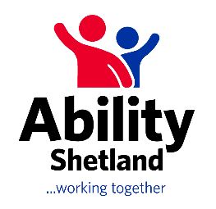

**JOB VACANCY**

Ability Shetland are looking for a dynamic and enthusiastic person to join our team as **Sports Development Coordinator**. They will co-ordinate and develop a range of physical activity and sport sessions and events for children, young people and adults with physical, learning and sensory disabilities across the Shetland Isles.

**Post Title: Sports Development Coordinator**

**Salary: Starting at £34,000 (includes Islands Allowance)**

**Hours: ​ 37 hours per week**

**Duration: ​ 3 year post subject to funding**

**Based: ​ Predominantly Market House (Third Sector Hub) in Lerwick.**

Partners including the local authority, third sector organisations and NHS Shetland recognise, through the Active Shetland Strategy Group, that it is evident there is a high demand and a lack of provision of inclusive physical activity and sport opportunities on the island. There is a lack of confidence within the sporting sector to offer inclusive opportunities and there is a need to change perceptions and change culture through education and training as there is currently a lag between philosophy and practice. The resource of a Sports Development Coordinator within the Ability Shetland team is essential to pull it all together and realise the ambitions of the island.

For further information and to request an application pack, please contact Stephanie Bain on [stephanie.bain@shetland.org](mailto:stephanie.bain@shetland.org)

Closing date for applications – 2nd June 2025

 