Adapted Bike Weekend
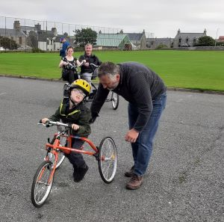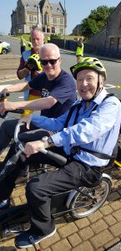

Disability Shetland, together with Shetland Sport for All, hosted some very successful adapted bike taster sessions over the weekend of 24th and 25th August. The sessions were funded as part of the Big Bike Revival project with Highland Cycle Ability Centre and a representative from Cycling UK bringing adapted bikes up to Shetland in order to deliver some very popular ‘come and try’ sessions.
On the Friday the bikes were enjoyed by adults from the Eric Gray @ Seafield Centre for a full on session at the Gilbertson Park – 19 people were able to use the adapted bikes and trikes. In the afternoon the bikes travelled to secondary and primary children with additional support needs to have a go of the variety of bikes and trikes to experience cycling too.
The first public event took place at the Brae High School Games hall on Saturday morning where people had the opportunity to try bucket bikes, trikes, recumbent bikes, tandems, running bikes and a hand bike. This was followed by an afternoon session at the Clickimin running track. The day was really well attended with 26 people coming along to try out some of the adapted bikes on offer.
On Sunday morning another ‘come and try’ session took place at the Gilbertson Park where 25 people turned up to take part. Donna Murray, chairperson for Shetland Sport for All, stated that “we were delighted that so many folk came along to have a go on the various bikes. The success of this weekend proves that we have a real need up here for having adapted bikes made available to folk. It was lovely to see people of different ages and abilities having access to bikes which gave them the opportunity to overcome some of the barriers that impact on them being able to access and enjoy cycling and being active”.
The bikes then travelled to the Shetland Sport and Leisure summer cycle and family fun event at the King George V play park where they were available for people to come and have a go. Stephanie Bain, Team Leader at Disability Shetland, stated that “we have seen so many people over the weekend, aged from 5 to 95 and of various abilities. We were so pleased to have given people opportunities to try cycling, return to cycling or to be cycled!” She also added “we were delighted to have been able to support even more people to get involved in community events, the smiles says it all really”.
Both Shetland Sport for All and Disability Shetland were delighted with the overall success of the weekend and have been truly inspired by everyone who attended the sessions, their families, carers and to all those who supported the event. They would like to sincerely thank Drew and Si from Highland Cycle Ability Centre and Paul from Cycling UK.
Of the number of people who attended over the weekend, many enjoyed it so much that they came along to both days. Lots of people came with their families and carers who also enjoyed having a go on the adapted bikes

