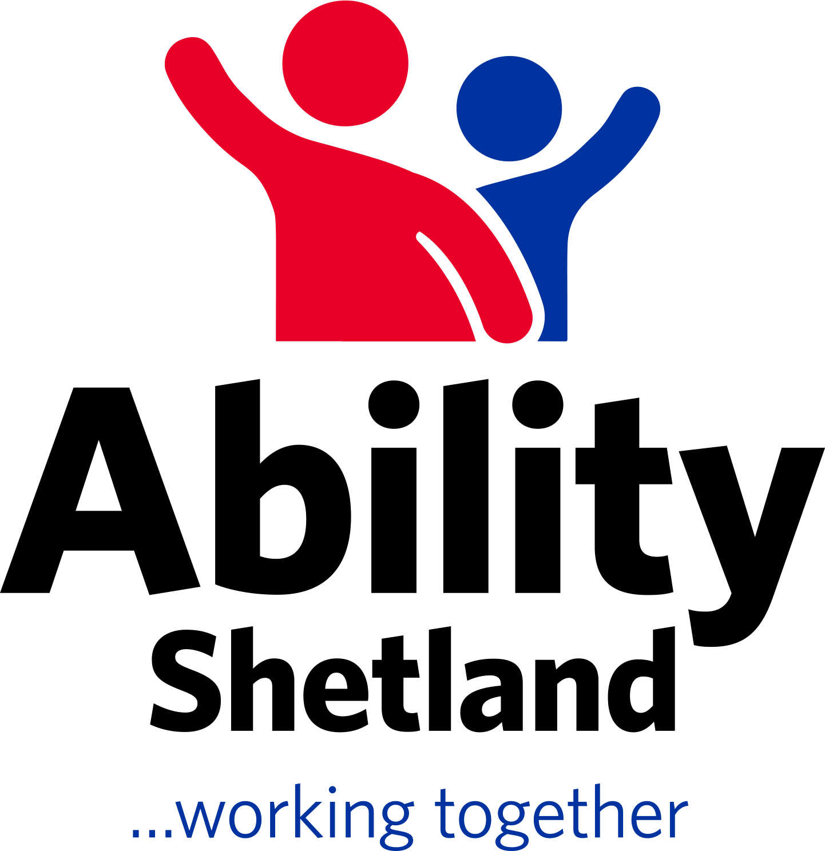
Ability Shetland,
Market House,
14 Market Street,
LERWICK.
ZE1 0JP
catriona.thomson3@shetland.org
www.abilityshetland.com

25/08/2024
Dear parent / carers

ASN October Holiday Clubs

Ability Shetland Holiday Clubs are for school aged children (3 to 19years) who have a disability and / or additional support needs. The Club is on from 10am to 3pm but half days can be requested. There will be a cost of £20 per day. Families must also provide lunch and snacks for their child, any sanitary products that their child may require during the day and appropriate clothing and footwear for the ever changing weather.

October club will run the first week of the holidays (14th-17th) with the following format:-

Monday- North Mainland & Lerwick
Tuesday- Lerwick
Wednesday -West Mainland & Lerwick
Thursday -Lerwick

We ask that you complete the booking form to request which days you would like your child/children to attend. As you are aware, the number of children and young people attending Holiday Club continues to increase and we are not always able to allocate families their full requests. As we are a registered childcare service with the Care Inspectorate, we have a limit to the numbers of children we can care for at any one time. Though you may not be allocated all days you request we will try our best and will aim to ensure our spaces are distributed as fairly as possible.

We ask that you get these back to us by 11th September so we can place children into appropriate groups with required staff numbers and then confirm what days you have.

Yours sincerely

Catriona Thomson

Holiday Club Coordinator– Ability Shetland

